THE TENDIK OUTPOST

THE UNKOWN-YET MAGIC ABOUT PLANET MERCURY DISCOVERIES WHERE MYTHS TURN INTO FACTS
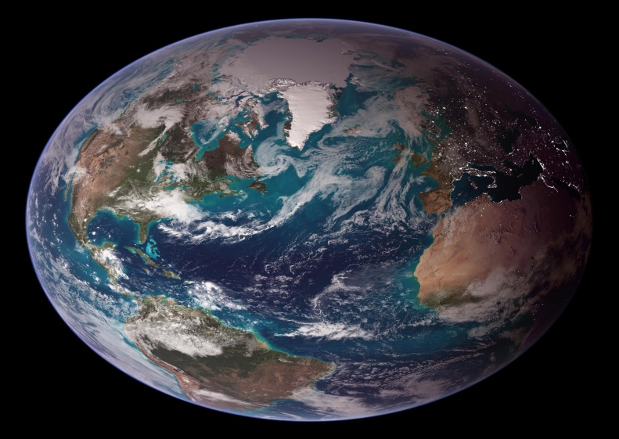
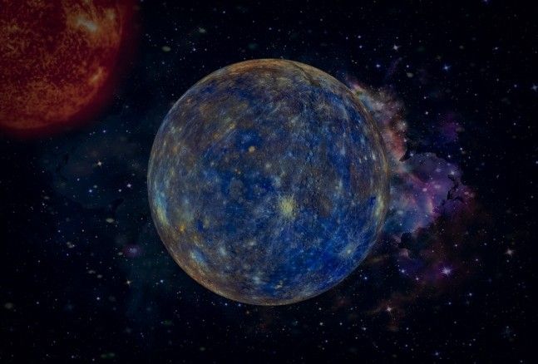
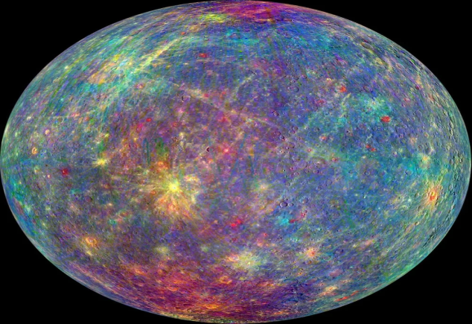

By: Commander Baron Mucurezi

The Tendik Outpost
First edition
Baron Mucurezi, the Tendik Commander
Victoria University Kampala, Uganda
Founder, the Tendik Journey to Planet Mercury

This edition revised by
Amina Okello
Senior Autonomous Mercury Ice & Navigation Assistant

Preface
Log by Commander Baron Mucurezi, Kampala, Uganda
Tendik Outpost, Prokofiev Crater, Mercury.
Fiction set in 2038, Science from MESSENGER, 2011-2015
The Tendik Outpost is fictional, set in 2038. Prokofiev crater, 112km, 100K permanent shadow, and dark organic lid theory are real, based on MESSENGER 2011-2015 data.

CHAPTER ONE

INTRODUCTION
Mercury is regarded to be the smallest planet in the Solar system and closest to the sun. Despite the fact that Mercury is the closest planet to the sun, it is not the hottest in our Solar system – the title being taken away by the nearby Venus.
Mercury exists with thin exosphere made up of atoms blasted off by the Solar wind and sticking meteoroids instead of being with an atmosphere like its fellow planets. This exosphere is composed of mainly oxygen, helium, hydrogen, sodium and potassium.
Being closest to the sun, it therefore experiences the day temperatures which can go as high as 800°F (430°C) (700K). And being a planet that lacks atmosphere, temperatures at night can reduce as low as -290°F (-180°C) (100K) to retain the heat that occurred during the day.

Ability to support life
These conditions make enough explanation as to why it’s regarded as unconducive to life since the temperatures and solar radiation that characterize this planet seem to be too extreme for organisms to adapt to.

Size and distance
Mercury stands with a radius of 1,516 miles (2,440 kilometers), just wider than 1/3 the width of Earth. It is positioned in an average distance of 36 million miles (58 million kilometers) away from the Sun and this much closeness to the sun makes sunlight to take 3.2 minutes to travel from the Sun to Planet Mercury, one of the reasons to extreme high tempertatures.
Standing on Mercury’s surface, the Sun appears more than three times as large as viewed from the Earth’s surface, and the sunlight, seven times brighter as much as it would be on Earth.

Formation and structure
Like all other terrestrial planets in the solar system, Mercury was also formed about 4.5 billion years ago when gravity pulled swrlings gas and dust together, has a central core, a solid crust and a rocky mantle but lacks the moons and rings.
It’s also regarded as the second dense planet after Earth with a large metallic core of about 1,289 miles (2,074 kilometers), which makes 85% of the planet’s radius.

Time and Periods
One Mercury Solar day (one full day-night cycle) equals 176 Earth days (4,224 Earth hours).

Orbits and Rotation
Mercury’s orbit takes the planet as close as 29 million miles (47 million kilometers) and as far as43 million miles (70 million kilometers) from the sun. It takes around the Sun every 88 Earth days, travelling through the space at nearly 29 miles (47 kilometers) per second, which makes it to be regarded as the fastest planet in the Solar system.
It completes one rotation on its axis every 59 Earth days and Mercury’s axis of rotation is tilted to just 2 degrees with respect to the plane of its orbit around the sun. This means it spins nearly perfectly upright which makes it fail to experience seasons like many other planets do.

CHAPTER TWO

MISSIONS TO PLANET MERCURY

THE NASA’S MESSENGER
A discovery mission launched on august 3, 2004, inserted on March 17, 2011, was the first ever robotic probe to orbit the planet Mercury.

Before NASA’s MESSENGER

They told us that mercury was a dead rock with no water.
That was marline in 1974. Half a planet mapped, no ice, case closed.
Then MESSENGER orbited from 2011 to 2015 and found it. Radar-bright ice in craters that never see sunlight. Upto 26 metres thick in Prokofiev. At 100 kelvin, -173 Celsius, where the sun never rises.

They told us the ice was pure.
It wasn’t. The brightest ice is covered by a dark layer. Tens of centimeters thick. Silicates or hydrocarbons, delivered by comets, or cooked by radiation. It has sharp edges. That means it’s young.

They did not tell us what was under the dark.
Here comes in the Prokofiev’s shadow

The Prokofiev’s shadow
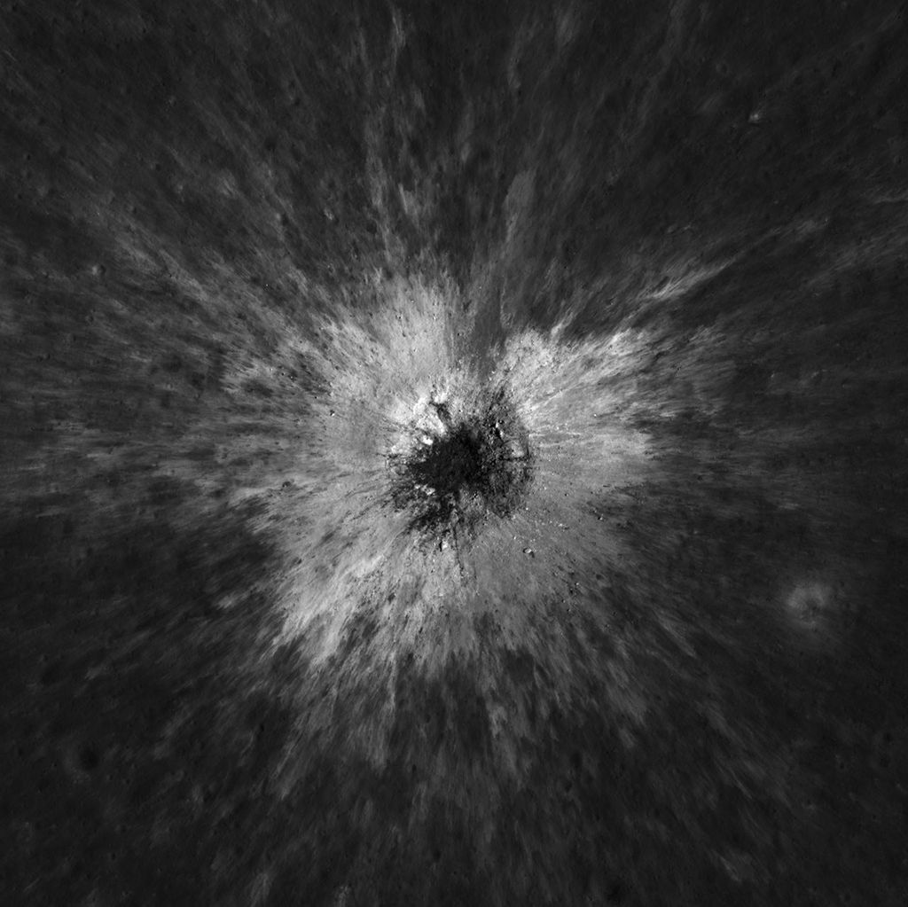
Just a week fresh in the year 2013, January 7, NASA’s MESSENGER spacecraft with the help of its Wide Angle Camera, managed to peer into the dark pits of mercury’s North Pole where it captured water ice sitting directly on the surface.
This place is said to be permanently shadowed located in the Prokofiev crater, the largest crater in the Mercury’s North Polar Region to host radar-bright material. This crater measures 112 kilometers (70 miles) in diameter.
The mechanism of behind this region being permanently shadowed is that Mercury has virtually no axial tilt. The rims of craters at its poles completely block out sunlight which creates this region of permanent shadow with temperatures as low as -280°F (-173°C) (100K), allowing water ice to remain stable for billions of years despite being the closest planet to the sun.

The prospect about the near future

The First Ugandan to Planet Mercury
I was hired to ignore the dark, mine the pure ice below, make propellant, and keep the lights on for Tendik Outpost.
On Sol 87, my drill hit 9m and stopped making sense.
The spectrometer spiked at 16, then 28, then a forest of peaks I had already seen in comet samples – methane, ethylene, something with a benzene ring that shouldn’t survive at 100 Kelvin.
In my ear, the delay light was red. Thirteen minutes to earth, thirteen minutes back. Whatever protocol said, I would be alone with the decision for twenty six-minutes.
I turned off the heater on the drill. The black layer stopped sublimating. It started to hold heat. I watched the thermal curve invert.
Ice was supposed to cool when heated it – energy goes to phase change, from solid to vapor. That’s why the drill was a heater. You sublimate, you capture, and you make water.
This didn’t cool. The temperature on the bit climbed. 120 Kelvin. 140. 170.

The dark was not reflecting heat. It was drinking it.
I then switched the drill to visual. The bore-camera had been blinded by ice glare by two months. Now, at 9m, it saw black.
Not rock, not regolith. A matte, granular black that filled the whole frame, like soot pressed into snow. And in the black, pores. Little bubbles, frozen mid-pop.
Cometary. It had to be cometary. MESSENGER had said the dark could be hydrocarbons delivered with the ice – but those were supposed to be a thin lag, centimetres left behind when ice sublimated away.
This was a metre thick. And it was structured.
At 180 Kelvin, the pores started to move.
A soft hiss hit the suit microphone – not through the radio, through the ground. Conduction. The ice below the dark was finally warming, vapour pushing up through the black like breath through a cloth.
The mass spec screamed again. Not water. Water was 18. This was 32, 44 – heavier, sticker. Methanol? Carbon dioxide trapped since the impact that made Prokofiev?
Then the drill torque dropped to zero. It wasn’t drilling anymore. It was falling.
The ice beneath the dark layer was gone. There was a void.
My boot lights flickered. In permanent shadow, you don’t have a horizon. You have crater walls lit by scattered light, and a hole you just opened to something that had not seen photons in a billion years.
From the hole, vapor rose. And it did not freeze.
Vapor in a vacuum should snow out. At 100 Kelvin, water molecules stick to the first cold surface they touch. They form frost instantly.
This vapor didn’t.
It rose two metres out of the hole, and then stopped, as if hitting a ceiling. It spread sideways, forming a flat, faint haze at chest height, catching her boot lights like dist. It was not freezing. It was floating.
I knelt. The bore-camera feed was gone – lost in the drop – but her helmet light could now look straight down the shaft.
The hole was not a void. It was a chamber.
The drill had punched through a roof.
Nine metres down, the walls changed from dirty ice to something smooth. The ice had been melted and refrozen. A melt lens. Around the edge, the black material was not granular it was layered, like varnish. Year after year, impact after impact, organics settling, and radiation baking it.
And at the bottom of the chamber – six metres down – was ice that was not radar-bright. It was clear, transparent, old ice. And inside it, trapped like insects in amber, were white grains.
Not bubbles. Grains that did not sublimate. Grains that were reflecting my light back.
BepiColombo missed it because MESSENGER had told it to look for white craters. The neutron spectrometer averaged over kilometers. Radar saw bright ice, or dark cover. It could not see a basement. This was a basement, a cold trap under a cold trap. The dark lag was not a tomb. It was a lid.
I had not found water. I had found a vault that had kept something from the early solar system at 100 Kelvin for four billion years.

The Vault
The lid holds. The vault at 100K is still at 100K. I sealed the hole on Sol 88. Vapor flat at 2m. The white grains are still there and I am not mining it. Protocol says wait for 26 minutes for Earth. I am waiting – Baron, Sol 87, Tendik.

